**Name: k reddy purandhar**

**Reg.no: 192011484**

**CODE: CSA0734**

**EXPERIMENT:18**

**AIM:** To implement of server-client using UDP socket programming.

**ALGORITHM:**

Server Side:

1. Create a socket: Create a UDP socket to listen for incoming client datagrams.
2. Bind the socket to an IP address and port number: Specify the IP address and port number for the server to listen on.
3. Receive datagrams from clients: Use the recvfrom() function to receive datagrams from clients.
4. Process the data: Process the received datagram as required by the application.
5. Send response to the client: Use the sendto() function to send a response back to the client, specifying the client's IP address and port number.
6. Repeat steps 3 to 5 as required to handle multiple clients.

**PROCEDURE:**

Client Side:

1. Create a socket: Create a UDP socket to send datagrams to the server.
2. Send data to the server: Use the sendto() function to send datagrams to the server, specifying the server's IP address and port number.
3. Receive response from the server: Use the recvfrom() function to receive a response from the server.
4. Process the response: Process the received response as required by the application.
5. Close the socket: Use the close() function to close the socket.
6. Exit the program: Exit the program as required.

**OUTPUT:**

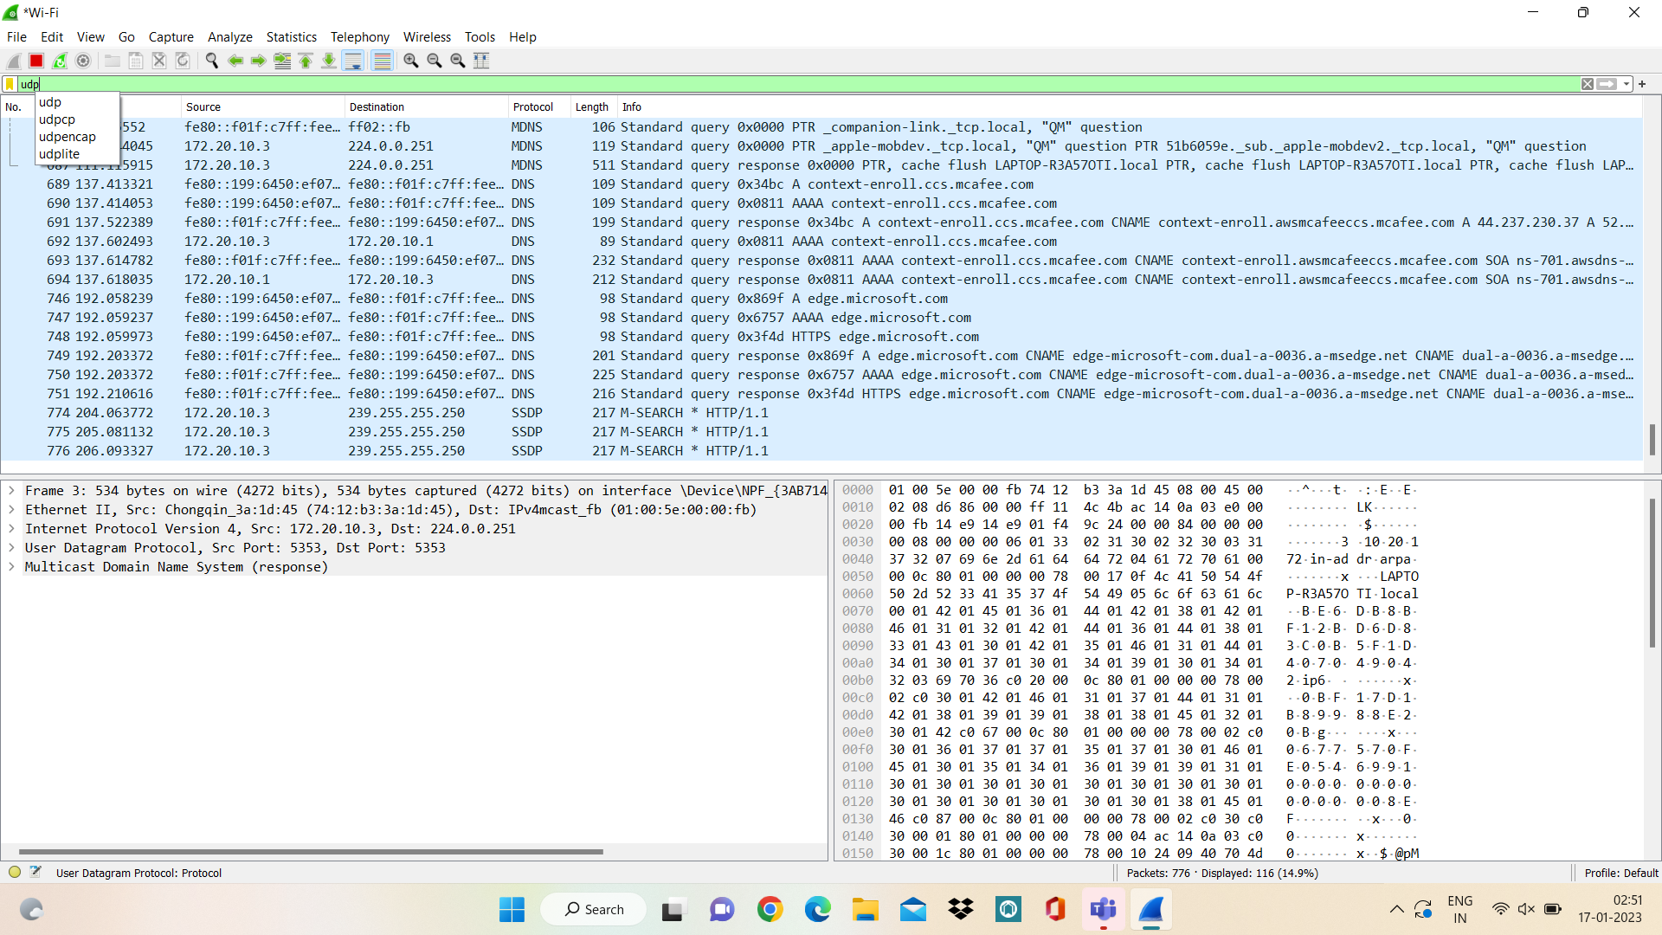

**RESULT:**

Therefore implementation of server—client using UDP socket programming.